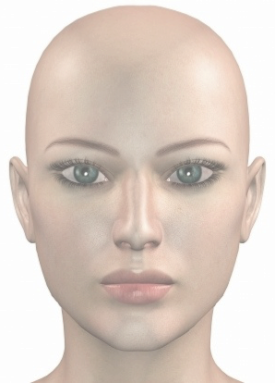
Dermal Filler- Doctor’s Record: (To be completed by practitioner)
L.A. & Prep used ______________________________________
Dermal Filler Product ___________________________________
Expiry_____________________________________
Batch No___________________________________
Total Volume Used (ml) ______________________
Any other notes _____________________________
Signature___________________________________
Name Printed________________________________
Date _______________________________________
Please depict areas treated and volumes used on diagram:

L.A. & Prep used ______________________________________
Dermal Filler Product ___________________________________
Expiry_____________________________________
Batch No___________________________________
Total Volume Used (ml) ______________________
Any other notes _____________________________
Signature___________________________________
Name Printed________________________________
Date _______________________________________
Please depict areas treated and volumes used on diagram:

