Aesthetic Interest Questionnaire | Date: __________________________________  Patient name: ___________________________  Date of birth: ____________________________

What is the main reason for your visit today?
I would like to be advised on:

- How I can look better for my age

- How I can change something that
has been bothering me for years

- How I can look more attractive

- Other:

Have you had a consultation or treatment  for a cosmetic procedure before? |  | How often do you think about wanting  a cosmetic procedure?
- Yes | - No | - Most days | - Weekly | - Monthly

Which three statements  best reflect how you would  like to look and feel after  the treatment? | - I want to look less tired  - I want to look less angry  - I want to look less sad | - I want a less saggy appearance  - I want to look more youthful  - I want to look more attractive | - I want my face to look slimmer  - I want softer features

Please circle the area(s) of your interest:
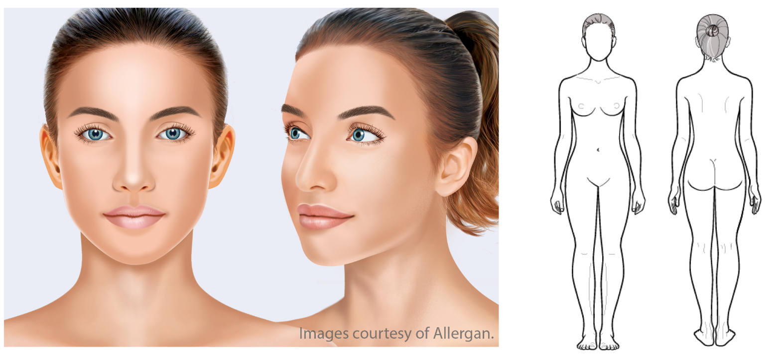

How would you rate the quality of your skin?  (Please circle the appropriate answer) | Poor | Fair | Good | Very Good | Excellent

If you could enhance an aspect of your skin, what would you enhance?  (Please circle the appropriate answer) | Hydration | Elasticity | Smoothness | Color

These treatments/products interest me:
(Please circle the treatment area(s) that interest you)

SKIN ENHANCEMENT | FACIAL IMPROVEMENT | BODY CONTOURING | OTHER
Skin injectables | Facial fillers | Fat reduction | Laser hair removal
Skin products | Wrinkle relaxers | Breast enlargement | Hair replacement
Laser treatment | Face lifting | Breast correction | Waxing
Peeling | Ear correction | Tummy tuck | Labiaplasty
Microdermabrasion | Fat reduction – chin | Arm lift | Scar revision
Facial | Nose surgery | Buttock augmentation
Skin tightening | Eyelid correction
 | Brow correction

How did you hear about us? |  | Contact information
- My doctor  - My insurance company provider  - Advertisements/periodicals  - A friend or family member | - Search engine  - Social media platform  - Seminar  - Other | - I would like to receive information about  new products/trends/our clinic  - You are allowed to contact me for further questions concerning an appointment at your clinic

Phone number: _________________________________________________

E-mail address: _________________________________________________

Signature: _____________________________________________________

Prepared by Allergan, January 2017, INT/0318/2016(1)

